

**Wildlife Project**

By:

Devomech Solutions Pvt. Ltd.

Date: 05-05-2023

# Current Progress:

* We tried to connect the GSM module with MQTT on TLS port, the security layer certificate problem was resolved for sim7000G but the device still didn’t connect to MQTT broker.
* The GSM module is compatible with LTE band (CAT-M and NB-IOT) which were not available on the previous SIM we were using.
* In order to communicate through the narrow band IOT (NB_IOT) we have to use special SIM card such as melita.io M2M SIM.
* The resp32 will use the time from SIM_MINI bat device and set on board esp32 RTC timer alarm which will wake up the esp32 from deep Sleep once day at 6:00AM and go to sleep again after posting data
* The overall flow diagram is as followed

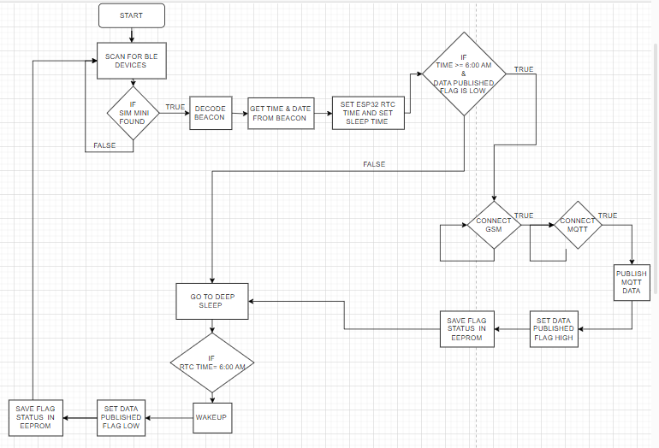

Figure 1 Flow Diagram

# Task for next week

* Use NB-IOT SIM card with SIM7000G module to connect to internet.
* Implement the overall flow and test the sleep and wakeup schedules.